DHCP SERVER CONFIGURATION

- To check system ip address #ifconfig
- To install package of dhcp server #yum install dhcp * -y
- To assign IP to dhcp server
        - #setup
- this will launch a new window select network configuration
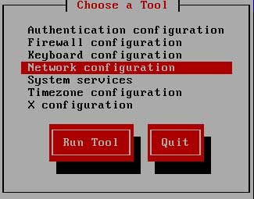
- Now a new window will show you all available LAN card select your LAN card

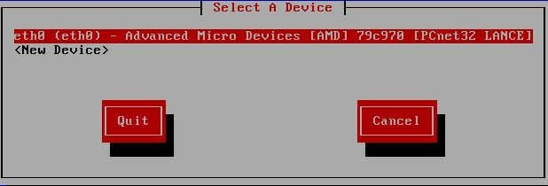
- Asign IP in this box and click ok
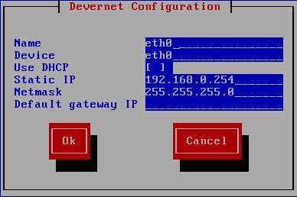

7. To simple configutarion file

#cp /usr/share/doc/dhcp-<4.2.5version_number>/dhcpd.conf.sample /etc/dhcp/dhcpd.conf

8 To edit configuration file #vi /etc/dhcp/dhcp.conf

O/T :se :nu 47.subnet 192.168.0.0 netmask 255.255.255.0{
48. range 192.168.0.60 192.168.0.70;
49. option domain name server 192.168.0.248
50. option domain name server “tesync.com”
51. option routers 192.168.0.178;
52. option broadcast-address 255.255.255.255
:wq (save)

9 To update the services #service dhcpd restart

10 Goto client system #dhclient -v

11 To check the system gateway ip address #route -n

12 To check allocated address on server. #cat /var/lib/dhcpd/dhcpd.leases

